USE PayFlowAnalytics;
GO

-- Q1. How many customers does the bank have?

SELECT
COUNT(*) AS total_customers
FROM analytics.customers;
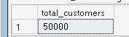

-- Q2. What is the average credit score of our customers?

SELECT
AVG(credit_score) AS average_credit_score
FROM analytics.customers;

-- Q3. What is the minimum credit score among our customers?

SELECT
MIN(credit_score) AS minimum_credit_score
FROM analytics.customers;

-- Q4. What is the maximum credit score among our customers?

SELECT
MAX(credit_score) AS maximum_credit_score
FROM analytics.customers;

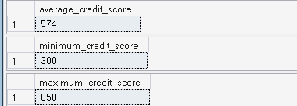

-- Q5. How many customers are there in each city?

SELECT
city,
COUNT(customer_id) AS customer_count
FROM analytics.customers
GROUP BY city;
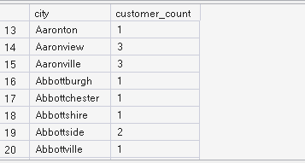

-- Q6. Which cities have the highest number of customers?

SELECT
city,
COUNT(customer_id) AS customer_count
FROM analytics.customers
GROUP BY city
ORDER BY customer_count DESC;
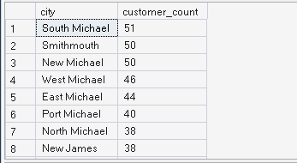

-- Q7. How many customers were created in each year?

SELECT
YEAR(created_at) AS customer_year,
COUNT(*) AS customer_count
FROM analytics.customers
GROUP BY YEAR(created_at)
ORDER BY customer_year;
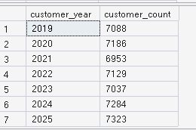

USE PayFlowAnalytics;
GO

-- Q1. How many customers are in each credit score category?

SELECT
CASE
WHEN credit_score BETWEEN 300 AND 579 THEN 'Low'
WHEN credit_score BETWEEN 580 AND 669 THEN 'Medium'
WHEN credit_score BETWEEN 670 AND 739 THEN 'Good'
ELSE 'Excellent'
END AS credit_category,
COUNT(*) AS customer_count
FROM analytics.customers
GROUP BY
CASE
WHEN credit_score BETWEEN 300 AND 579 THEN 'Low'
WHEN credit_score BETWEEN 580 AND 669 THEN 'Medium'
WHEN credit_score BETWEEN 670 AND 739 THEN 'Good'
ELSE 'Excellent'
END
ORDER BY customer_count DESC;
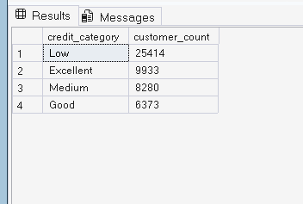

-- Q2. What percentage of customers belong to each credit score category?

SELECT
CASE
WHEN credit_score BETWEEN 300 AND 579 THEN 'Low'
WHEN credit_score BETWEEN 580 AND 669 THEN 'Medium'
WHEN credit_score BETWEEN 670 AND 739 THEN 'Good'
ELSE 'Excellent'
END AS credit_category,
COUNT(*) AS customer_count,
COUNT(*) * 100.0 / (SELECT COUNT(*) FROM analytics.customers) AS percentage
FROM analytics.customers
GROUP BY
CASE
WHEN credit_score BETWEEN 300 AND 579 THEN 'Low'
WHEN credit_score BETWEEN 580 AND 669 THEN 'Medium'
WHEN credit_score BETWEEN 670 AND 739 THEN 'Good'
ELSE 'Excellent'
END
ORDER BY percentage DESC;
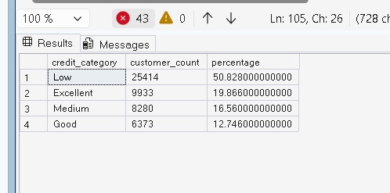

-- Q3. How many customers have a credit score below 580?

SELECT
COUNT(*) AS customers_below_580
FROM analytics.customers
WHERE credit_score < 580;
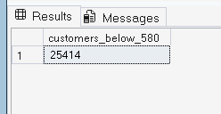

-- Q4. How many customers have a credit score of 740 or above?

SELECT
COUNT(*) AS customers_740_or_above
FROM analytics.customers
WHERE credit_score >= 740;
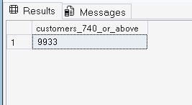

-- Q5. What are the top 10 cities by number of customers?

SELECT TOP 10
city,
COUNT(*) AS customer_count
FROM analytics.customers
GROUP BY city
ORDER BY customer_count DESC;
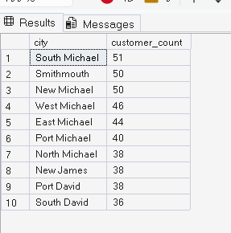

-- Q6. What are the bottom 10 cities by number of customers?

SELECT TOP 10
city,
COUNT(*) AS customer_count
FROM analytics.customers
GROUP BY city
ORDER BY customer_count ASC;
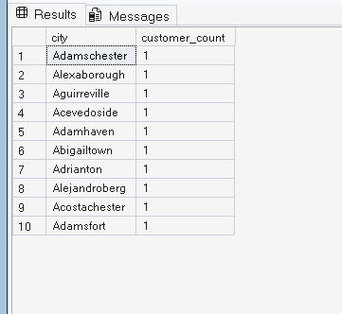

USE PayFlowAnalytics;
GO

-- Q1. What are the top 10 cities by number of customers?

SELECT TOP 10
city,
COUNT(*) AS customer_count
FROM analytics.customers
GROUP BY city
ORDER BY customer_count DESC;
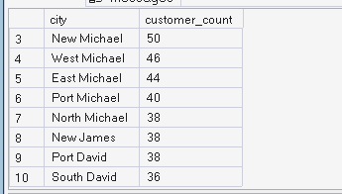

-- Q2. What percentage of our total customers belong to each city?

SELECT
city,
COUNT(*) AS customer_count,
COUNT(*) * 100.0 /
(SELECT COUNT(*) FROM analytics.customers) AS percentage
FROM analytics.customers
GROUP BY city
ORDER BY percentage DESC;
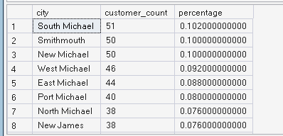

-- Q3. How many different cities do our customers come from?

SELECT
COUNT(DISTINCT city) AS total_cities
FROM analytics.customers;


-- Q4. Which city has the largest customer base?

SELECT TOP 1
city,
COUNT(*) AS customer_count
FROM analytics.customers
GROUP BY city
ORDER BY customer_count DESC;
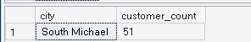

-- Q5. What is the average credit score in each city?

SELECT
city,
COUNT(*) AS customer_count,
AVG(credit_score) AS average_credit_score
FROM analytics.customers
GROUP BY city
ORDER BY average_credit_score DESC;
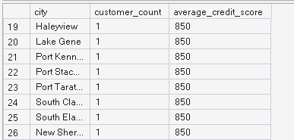

USE PayFlowAnalytics;
GO
-- Q1. How many customers were acquired each year?

SELECT
YEAR(created_at) AS customer_year,
COUNT(*) AS customer_count
FROM analytics.customers
GROUP BY YEAR(created_at)
ORDER BY customer_year;
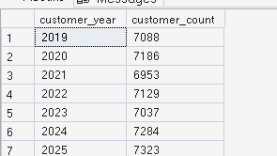

-- Q2. What percentage of total customers were acquired each year?

SELECT
YEAR(created_at) AS customer_year,
COUNT(*) AS customer_count,
COUNT(*) * 100.0 /
(SELECT COUNT(*) FROM analytics.customers) AS acquisition_percentage
FROM analytics.customers
GROUP BY YEAR(created_at)
ORDER BY customer_year;
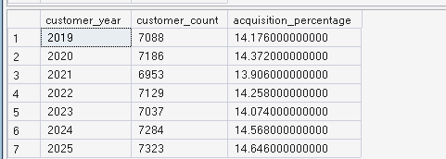

-- Q3. Which year had the highest customer acquisition?

SELECT TOP 1
YEAR(created_at) AS customer_year,
COUNT(*) AS customer_count
FROM analytics.customers
GROUP BY YEAR(created_at)
ORDER BY customer_count DESC;

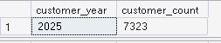
-- Q4. Which year had the lowest customer acquisition?

SELECT TOP 1
YEAR(created_at) AS customer_year,
COUNT(*) AS customer_count
FROM analytics.customers
GROUP BY YEAR(created_at)
ORDER BY customer_count ASC;
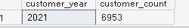

-- Q1. What is the total account balance held by each customer?

SELECT
customer_id,
SUM(balance_usd) AS total_balance
FROM analytics.accounts
GROUP BY customer_id;
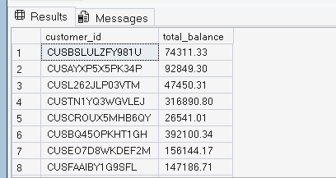

-- Q2. Who are the top 10 customers by total account balance?

SELECT TOP 10
customer_id,
SUM(balance_usd) AS total_balance
FROM analytics.accounts
GROUP BY customer_id
ORDER BY total_balance DESC;
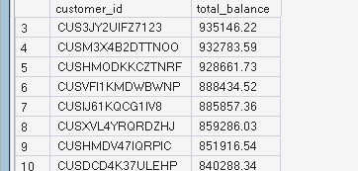

-- Q3. What is the average total balance held per customer?

SELECT
AVG(total_balance) AS average_customer_balance
FROM
(
SELECT
customer_id,
SUM(balance_usd) AS total_balance
FROM analytics.accounts
GROUP BY customer_id
) AS customer_balances;
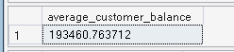

-- Q4. How many customers have total balances above $100,000?

SELECT
COUNT(*) AS customers_above_100k
FROM
(
SELECT
customer_id,
SUM(balance_usd) AS total_balance
FROM analytics.accounts
GROUP BY customer_id
HAVING SUM(balance_usd) > 100000
) AS high_balance_customers;
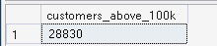

-- Q5. Which customers have both a credit score of 740+
-- and a total account balance above $100,000?

SELECT
c.customer_id,
c.first_name,
c.last_name,
c.credit_score,
SUM(a.balance_usd) AS total_balance
FROM analytics.customers c
JOIN analytics.accounts a
ON c.customer_id = a.customer_id
WHERE c.credit_score >= 740
GROUP BY
c.customer_id,
c.first_name,
c.last_name,
c.credit_score
HAVING SUM(a.balance_usd) > 100000
ORDER BY total_balance DESC;

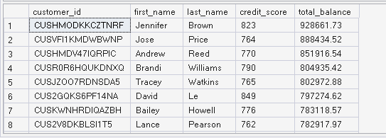

-- Q1. How many accounts have valid vs invalid dates?

SELECT
account_date_valid,
COUNT(*) AS account_count
FROM analytics.accounts
GROUP BY account_date_valid;
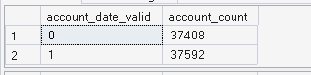

-- Q2. What percentage of accounts are valid vs invalid?

SELECT
account_date_valid,
COUNT(*) AS account_count,
COUNT(*) * 100.0 /
(SELECT COUNT(*) FROM analytics.accounts) AS account_percentage
FROM analytics.accounts
GROUP BY account_date_valid;

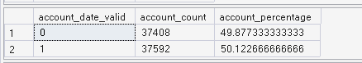
-- Q3. What is the total balance in valid vs invalid accounts?

SELECT
account_date_valid,
SUM(balance_usd) AS total_balance
FROM analytics.accounts
GROUP BY account_date_valid;
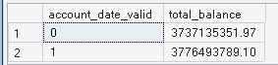

-- Q4. What is the average balance of valid vs invalid accounts?

SELECT
account_date_valid,
AVG(balance_usd) AS average_balance
FROM analytics.accounts
GROUP BY account_date_valid;
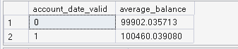

-- Q5. How many accounts have a balance above $100,000?

SELECT
COUNT(*) AS accounts_above_100k
FROM analytics.accounts
WHERE balance_usd > 100000;

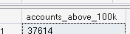
-- Q6. What are the 10 accounts with the highest balances?

SELECT TOP 10
account_id,
customer_id,
account_type,
balance_usd,
account_date_valid
FROM analytics.accounts
ORDER BY balance_usd DESC;
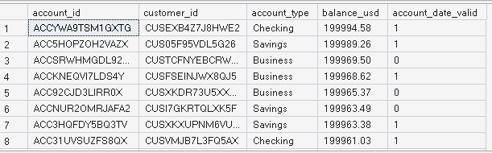

-- Q1. Show each account along with the customer's name

SELECT
c.customer_id,
c.first_name,
c.last_name,
a.account_id,
a.account_type,
a.balance_usd
FROM analytics.customers c
JOIN analytics.accounts a
ON c.customer_id = a.customer_id;
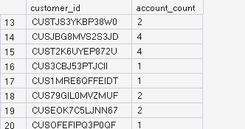

-- Q2. How many accounts does each customer have, along with their name?

SELECT
c.customer_id,
c.first_name,
c.last_name,
COUNT(a.account_id) AS account_count
FROM analytics.customers c
JOIN analytics.accounts a
ON c.customer_id = a.customer_id
GROUP BY
c.customer_id,
c.first_name,
c.last_name
ORDER BY account_count DESC;


-- Q3. What is the total balance held by each customer,
-- along with their name and credit score?

SELECT
c.customer_id,
c.first_name,
c.last_name,
c.credit_score,
SUM(a.balance_usd) AS total_balance
FROM analytics.customers c
JOIN analytics.accounts a
ON c.customer_id = a.customer_id
GROUP BY
c.customer_id,
c.first_name,
c.last_name,
c.credit_score
ORDER BY total_balance DESC;
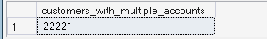

-- Q4. Who are the top 10 customers by total balance?

SELECT TOP 10
c.customer_id,
c.first_name,
c.last_name,
c.credit_score,
SUM(a.balance_usd) AS total_balance
FROM analytics.customers c
JOIN analytics.accounts a
ON c.customer_id = a.customer_id
GROUP BY
c.customer_id,
c.first_name,
c.last_name,
c.credit_score
ORDER BY total_balance DESC;
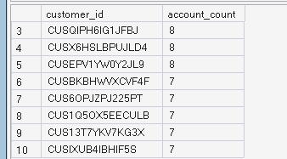

-- Q5. What is the average total balance for each credit-score category?

SELECT
credit_category,
AVG(total_balance) AS average_total_balance
FROM
(
SELECT
c.customer_id,
CASE
WHEN c.credit_score BETWEEN 300 AND 579 THEN 'Low'
WHEN c.credit_score BETWEEN 580 AND 669 THEN 'Medium'
WHEN c.credit_score BETWEEN 670 AND 739 THEN 'Good'
ELSE 'Excellent'
END AS credit_category,
SUM(a.balance_usd) AS total_balance
FROM analytics.customers c
JOIN analytics.accounts a
ON c.customer_id = a.customer_id
GROUP BY
c.customer_id,
c.credit_score
) AS customer_balances
GROUP BY credit_category
ORDER BY average_total_balance DESC;
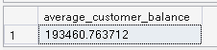

-- Q6. Which credit-score category holds the most total money?

SELECT TOP 1
credit_category,
SUM(total_balance) AS total_balance
FROM
(
SELECT
c.customer_id,
CASE
WHEN c.credit_score BETWEEN 300 AND 579 THEN 'Low'
WHEN c.credit_score BETWEEN 580 AND 669 THEN 'Medium'
WHEN c.credit_score BETWEEN 670 AND 739 THEN 'Good'
ELSE 'Excellent'
END AS credit_category,
SUM(a.balance_usd) AS total_balance
FROM analytics.customers c
JOIN analytics.accounts a
ON c.customer_id = a.customer_id
GROUP BY
c.customer_id,
c.credit_score
) AS customer_balances
GROUP BY credit_category
ORDER BY total_balance DESC;
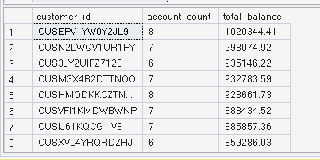

-- Q1. How many cards do we have for each card type?

SELECT
card_type,
COUNT(*) AS card_count
FROM analytics.cards
GROUP BY card_type;

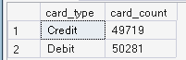
-- Q2. What percentage of cards does each card type represent?

SELECT
card_type,
COUNT(*) AS card_count,
COUNT(*) * 100.0 /
(SELECT COUNT(*) FROM analytics.cards) AS card_percentage
FROM analytics.cards
GROUP BY card_type
ORDER BY card_percentage DESC;
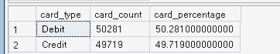

-- Q3. How many cards are active vs expired?

SELECT
card_status,
COUNT(*) AS card_count
FROM analytics.cards
GROUP BY card_status;

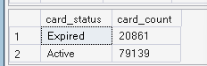
-- Q4. What percentage of all cards are expired?

SELECT
COUNT(*) AS expired_cards,
COUNT(*) * 100.0 /
(SELECT COUNT(*) FROM analytics.cards) AS expired_percentage
FROM analytics.cards
WHERE card_status = 'Expired';

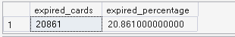
-- Q5. How many cards expire in each year?

SELECT
YEAR(expiration_date) AS expiration_year,
COUNT(*) AS card_count
FROM analytics.cards
GROUP BY YEAR(expiration_date)
ORDER BY expiration_year;
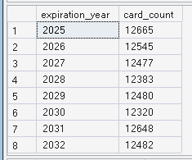

-- Q6. What are the top 10 accounts with the most cards?

SELECT TOP 10
account_id,
COUNT(card_id) AS card_count
FROM analytics.cards
GROUP BY account_id
ORDER BY card_count DESC;
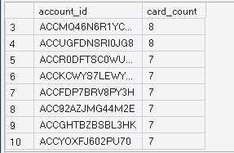

-- Q7. Which card types have the highest expiration risk?

SELECT
card_type,
COUNT(*) AS total_cards,
SUM(
CASE
WHEN card_status = 'Expired' THEN 1
ELSE 0
END
) AS expired_cards,
SUM(
CASE
WHEN card_status = 'Expired' THEN 1
ELSE 0
END
) * 100.0 / COUNT(*) AS expired_percentage
FROM analytics.cards
GROUP BY card_type
ORDER BY expired_percentage DESC;

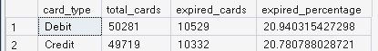

-- Q1. How many loans does the bank have?

SELECT
COUNT(*) AS total_loans
FROM analytics.loans;
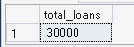

-- Q2. What is the total amount of money lent by the bank?

SELECT
SUM(loan_amount) AS total_loan_amount
FROM analytics.loans;

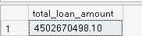
-- Q3. What is the average loan amount?

SELECT
AVG(loan_amount) AS average_loan_amount
FROM analytics.loans;
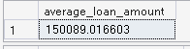

-- Q4. What are the minimum and maximum loan amounts?

SELECT
MIN(loan_amount) AS minimum_loan_amount,
MAX(loan_amount) AS maximum_loan_amount
FROM analytics.loans;

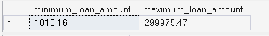
-- Q5. What is the average interest rate?

SELECT
AVG(interest_rate) AS average_interest_rate
FROM analytics.loans;
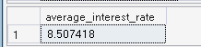

-- Q6. How many loans are Small, Medium, and Large?

SELECT
CASE
WHEN loan_amount < 50000 THEN 'Small'
WHEN loan_amount BETWEEN 50000 AND 100000 THEN 'Medium'
ELSE 'Large'
END AS loan_category,
COUNT(*) AS loan_count
FROM analytics.loans
GROUP BY

CASE
WHEN loan_amount < 50000 THEN 'Small'
WHEN loan_amount BETWEEN 50000 AND 100000 THEN 'Medium'
ELSE 'Large'
END;
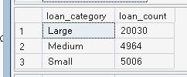

-- Q7. What is the total loan amount for each loan-size category?

SELECT
CASE
WHEN loan_amount < 50000 THEN 'Small'
WHEN loan_amount BETWEEN 50000 AND 100000 THEN 'Medium'
ELSE 'Large'
END AS loan_category,
SUM(loan_amount) AS total_loan_amount
FROM analytics.loans
GROUP BY
CASE
WHEN loan_amount < 50000 THEN 'Small'
WHEN loan_amount BETWEEN 50000 AND 100000 THEN 'Medium'
ELSE 'Large'
END
ORDER BY total_loan_amount DESC;
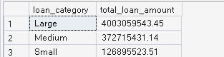

-- Q8. Which loan category has the highest total loan amount?

SELECT TOP 1
CASE
WHEN loan_amount < 50000 THEN 'Small'
WHEN loan_amount BETWEEN 50000 AND 100000 THEN 'Medium'
ELSE 'Large'
END AS loan_category,
SUM(loan_amount) AS total_loan_amount
FROM analytics.loans
GROUP BY
CASE
WHEN loan_amount < 50000 THEN 'Small'
WHEN loan_amount BETWEEN 50000 AND 100000 THEN 'Medium'
ELSE 'Large'
END
ORDER BY total_loan_amount DESC;
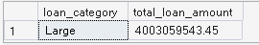
USE PayFlowAnalytics;
GO
-- Q1. Show each loan with the customer's name and credit score.

SELECT
l.loan_id,
l.customer_id,
c.first_name,
c.last_name,
c.credit_score,
l.loan_amount,
l.interest_rate
FROM analytics.loans l
JOIN analytics.customers c
ON l.customer_id = c.customer_id;
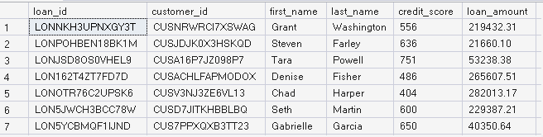

-- Q2. What is the total loan amount for each customer?

SELECT
c.customer_id,
c.first_name,
c.last_name,
SUM(l.loan_amount) AS total_loan_amount
FROM analytics.customers c
JOIN analytics.loans l
ON c.customer_id = l.customer_id
GROUP BY
c.customer_id,
c.first_name,
c.last_name
ORDER BY total_loan_amount DESC;
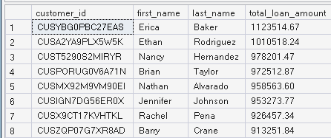

-- Q3. What is the average loan amount for each credit-score category?

SELECT
CASE
WHEN c.credit_score BETWEEN 300 AND 579 THEN 'Low'
WHEN c.credit_score BETWEEN 580 AND 669 THEN 'Medium'
WHEN c.credit_score BETWEEN 670 AND 739 THEN 'Good'
ELSE 'Excellent'
END AS credit_category,
AVG(l.loan_amount) AS average_loan_amount
FROM analytics.customers c
JOIN analytics.loans l
ON c.customer_id = l.customer_id
GROUP BY
CASE
WHEN c.credit_score BETWEEN 300 AND 579 THEN 'Low'
WHEN c.credit_score BETWEEN 580 AND 669 THEN 'Medium'
WHEN c.credit_score BETWEEN 670 AND 739 THEN 'Good'
ELSE 'Excellent'
END
ORDER BY average_loan_amount DESC;
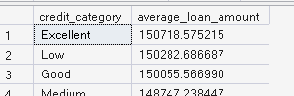

-- Q4. Who are the top 10 customers by total loan amount?

SELECT TOP 10
c.customer_id,
c.first_name,
c.last_name,
c.credit_score,
SUM(l.loan_amount) AS total_loan_amount
FROM analytics.customers c
JOIN analytics.loans l
ON c.customer_id = l.customer_id
GROUP BY
c.customer_id,
c.first_name,
c.last_name,
c.credit_score
ORDER BY total_loan_amount DESC;
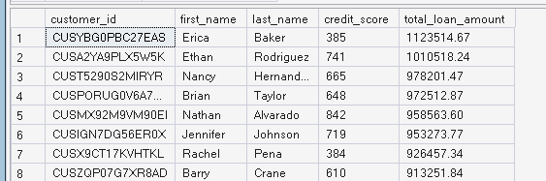

-- Q5. How many customers with credit score below 670
-- have loans above $100,000?

SELECT
COUNT(DISTINCT c.customer_id) AS customer_count
FROM analytics.customers c
JOIN analytics.loans l
ON c.customer_id = l.customer_id
WHERE
c.credit_score < 670
AND l.loan_amount > 100000;

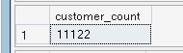
Q6. Which credit-score category has the highest total loan amount?

SELECT TOP 1
CASE
WHEN c.credit_score BETWEEN 300 AND 579 THEN 'Low'
WHEN c.credit_score BETWEEN 580 AND 669 THEN 'Medium'
WHEN c.credit_score BETWEEN 670 AND 739 THEN 'Good'
ELSE 'Excellent'
END AS credit_category,
SUM(l.loan_amount) AS total_loan_amount
FROM analytics.customers c
JOIN analytics.loans l
ON c.customer_id = l.customer_id
GROUP BY
CASE
WHEN c.credit_score BETWEEN 300 AND 579 THEN 'Low'
WHEN c.credit_score BETWEEN 580 AND 669 THEN 'Medium'
WHEN c.credit_score BETWEEN 670 AND 739 THEN 'Good'
ELSE 'Excellent'
END
ORDER BY total_loan_amount DESC;

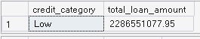
-- Q7. Compare loan amount and interest rate by credit-score category.

SELECT
CASE
WHEN c.credit_score BETWEEN 300 AND 579 THEN 'Low'
WHEN c.credit_score BETWEEN 580 AND 669 THEN 'Medium'
WHEN c.credit_score BETWEEN 670 AND 739 THEN 'Good'
ELSE 'Excellent'
END AS credit_category,
COUNT(*) AS loan_count,
SUM(l.loan_amount) AS total_loan_amount,
AVG(l.loan_amount) AS average_loan_amount,
AVG(l.interest_rate) AS average_interest_rate
FROM analytics.customers c
JOIN analytics.loans l
ON c.customer_id = l.customer_id
GROUP BY
CASE
WHEN c.credit_score BETWEEN 300 AND 579 THEN 'Low'
WHEN c.credit_score BETWEEN 580 AND 669 THEN 'Medium'
WHEN c.credit_score BETWEEN 670 AND 739 THEN 'Good'
ELSE 'Excellent'
END
ORDER BY total_loan_amount DESC;
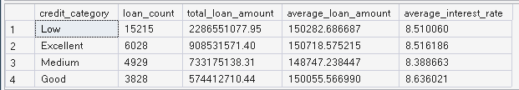

-- Q1. What is the total number of transactions and total transaction value?

SELECT
COUNT(*) AS total_transactions,
SUM(amount_usd) AS total_transaction_value
FROM analytics.transactions;
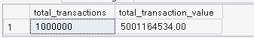

-- Q2. What is the average, minimum and maximum transaction amount?

SELECT
AVG(amount_usd) AS average_transaction_amount,
MIN(amount_usd) AS minimum_transaction_amount,
MAX(amount_usd) AS maximum_transaction_amount
FROM analytics.transactions;

-- Q3. What is the transaction volume and value by month?

SELECT
YEAR(transaction_date) AS transaction_year,
MONTH(transaction_date) AS transaction_month,
COUNT(*) AS transaction_count,
SUM(amount_usd) AS total_transaction_value
FROM analytics.transactions
GROUP BY
YEAR(transaction_date),
MONTH(transaction_date)
ORDER BY
transaction_year,
transaction_month;
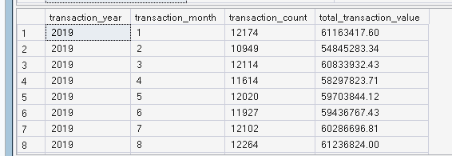

-- Q4. What are the top 10 merchants by transaction value?

SELECT TOP 10
merchant_id,
SUM(amount_usd) AS total_transaction_value
FROM analytics.transactions
GROUP BY merchant_id
ORDER BY total_transaction_value DESC;
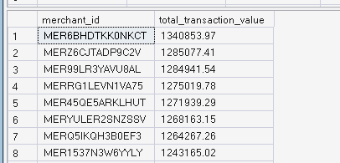

-- Q5. What are the top 10 highest individual transactions?

SELECT TOP 10
transaction_id,
account_id,
amount_usd,
transaction_date
FROM analytics.transactions
ORDER BY amount_usd DESC;
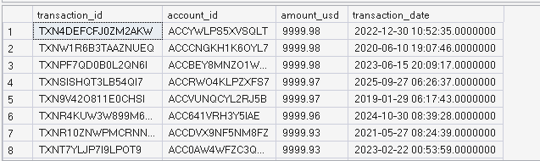

-- Q6. Which months had the highest transaction volume?

SELECT
YEAR(transaction_date) AS transaction_year,
MONTH(transaction_date) AS transaction_month,
COUNT(*) AS transaction_count
FROM analytics.transactions
GROUP BY
YEAR(transaction_date),
MONTH(transaction_date)
ORDER BY transaction_count DESC;
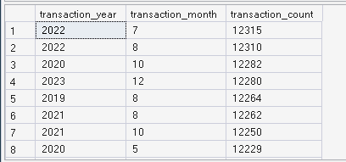
USE PayFlowAnalytics;
GO

-- Q1. What is the total transaction value for each merchant?

SELECT
merchant_id,
SUM(amount_usd) AS total_transaction_value
FROM analytics.transactions
GROUP BY merchant_id
ORDER BY total_transaction_value DESC;
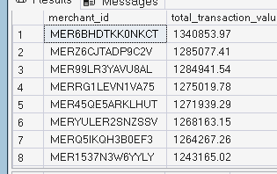

-- Q2. What are the top 10 merchants by transaction value?

SELECT TOP 10
merchant_id,
SUM(amount_usd) AS total_transaction_value
FROM analytics.transactions
GROUP BY merchant_id
ORDER BY total_transaction_value DESC;
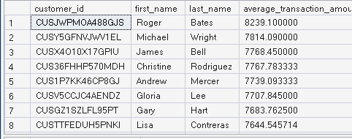

-- Q3. Which customers have an average transaction amount above $5,000?

SELECT
c.customer_id,
c.first_name,
c.last_name,
AVG(t.amount_usd) AS average_transaction_amount
FROM analytics.transactions t
JOIN analytics.accounts a
ON t.account_id = a.account_id
JOIN analytics.customers c
ON a.customer_id = c.customer_id
GROUP BY
c.customer_id,
c.first_name,
c.last_name
HAVING AVG(t.amount_usd) > 5000
ORDER BY average_transaction_amount DESC;

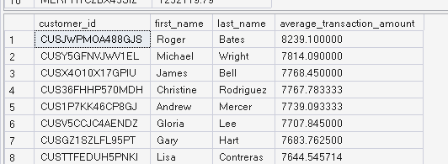
-- Q4. How many transactions are above $10,000?

SELECT
COUNT(*) AS high_value_transactions
FROM analytics.transactions
WHERE amount_usd > 10000;
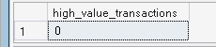

-- Q5. What percentage of transactions are above $10,000?

SELECT
COUNT(*) AS high_value_transactions,
COUNT(*) * 100.0 /
(SELECT COUNT(*) FROM analytics.transactions) AS high_value_percentage
FROM analytics.transactions
WHERE amount_usd > 10000;

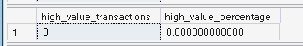
-- Q6. What is the highest transaction amount for each customer?

SELECT
c.customer_id,
c.first_name,
c.last_name,
MAX(t.amount_usd) AS highest_transaction
FROM analytics.transactions t
JOIN analytics.accounts a
ON t.account_id = a.account_id
JOIN analytics.customers c
ON a.customer_id = c.customer_id
GROUP BY
c.customer_id,
c.first_name,
c.last_name
ORDER BY highest_transaction DESC;
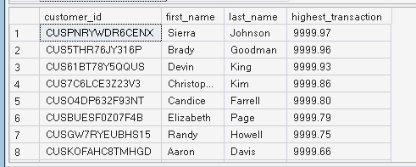

USE PayFlowAnalytics;
GO

-- Q1. Show customers with their account details.

SELECT
c.customer_id,
c.first_name,
c.last_name,
a.account_id,
a.account_type,
a.balance_usd
FROM analytics.customers c
JOIN analytics.accounts a
ON c.customer_id = a.customer_id;
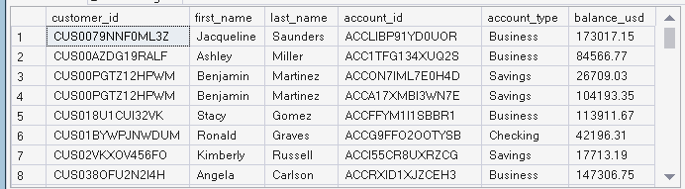

-- Q2. Find the top 10 customers by total account balance.

SELECT TOP 10
c.customer_id,
c.first_name,
c.last_name,
SUM(a.balance_usd) AS total_balance
FROM analytics.customers c
JOIN analytics.accounts a
ON c.customer_id = a.customer_id
GROUP BY
c.customer_id,
c.first_name,
c.last_name
ORDER BY total_balance DESC;

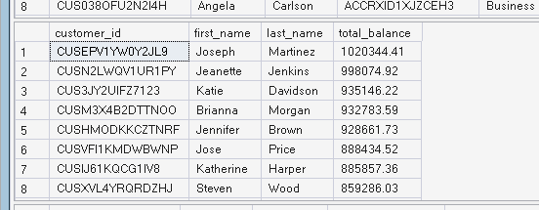
-- Q3. Show customers with their total loan amount.

SELECT
c.customer_id,
c.first_name,
c.last_name,
SUM(l.loan_amount) AS total_loan_amount
FROM analytics.customers c
JOIN analytics.loans l
ON c.customer_id = l.customer_id
GROUP BY
c.customer_id,
c.first_name,
c.last_name
ORDER BY total_loan_amount DESC;
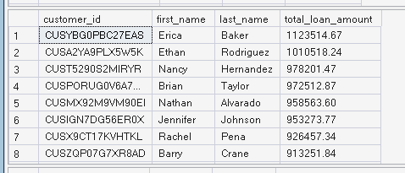

-- Q4. Find customers who have both an account and a loan.

SELECT DISTINCT
c.customer_id,
c.first_name,
c.last_name
FROM analytics.customers c
JOIN analytics.accounts a
ON c.customer_id = a.customer_id
JOIN analytics.loans l
ON c.customer_id = l.customer_id;
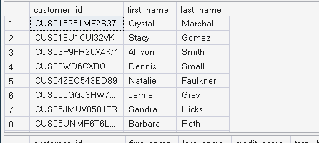

-- Q5. Create a customer-level banking summary.

WITH account_summary AS
(
SELECT
customer_id,
SUM(balance_usd) AS total_balance
FROM analytics.accounts
GROUP BY customer_id
),
loan_summary AS
(
SELECT
customer_id,
SUM(loan_amount) AS total_loan_amount
FROM analytics.loans
GROUP BY customer_id
)
SELECT
c.customer_id,
c.first_name,
c.last_name,
c.credit_score,
COALESCE(a.total_balance, 0) AS total_balance,
COALESCE(l.total_loan_amount, 0) AS total_loan_amount
FROM analytics.customers c
LEFT JOIN account_summary a
ON c.customer_id = a.customer_id
LEFT JOIN loan_summary l
ON c.customer_id = l.customer_id;
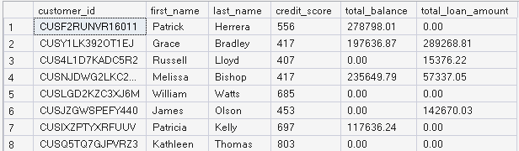

-- Q6. Find the top 10 customers by financial exposure.

WITH account_summary AS
(
SELECT
customer_id,
SUM(balance_usd) AS total_balance
FROM analytics.accounts
GROUP BY customer_id
),
loan_summary AS
(
SELECT
customer_id,
SUM(loan_amount) AS total_loan_amount
FROM analytics.loans
GROUP BY customer_id
)
SELECT TOP 10
c.customer_id,
c.first_name,
c.last_name,
COALESCE(a.total_balance, 0) AS total_balance,
COALESCE(l.total_loan_amount, 0) AS total_loan_amount,
COALESCE(a.total_balance, 0)
+ COALESCE(l.total_loan_amount, 0) AS financial_exposure
FROM analytics.customers c
LEFT JOIN account_summary a
ON c.customer_id = a.customer_id
LEFT JOIN loan_summary l
ON c.customer_id = l.customer_id
ORDER BY financial_exposure DESC;
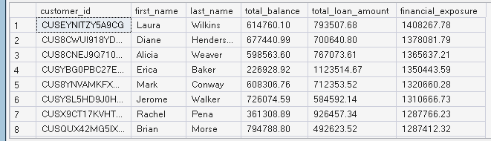

-- Q7. Calculate overall banking KPIs.

SELECT
(SELECT COUNT(*) FROM analytics.customers) AS total_customers,
(SELECT COUNT(*) FROM analytics.accounts) AS total_accounts,
(SELECT COUNT(*) FROM analytics.loans) AS total_loans,
(SELECT SUM(loan_amount) FROM analytics.loans) AS total_loan_amount,
(SELECT SUM(balance_usd) FROM analytics.accounts) AS total_account_balance,
(SELECT COUNT(*) FROM analytics.transactions) AS total_transactions,
(SELECT SUM(amount_usd) FROM analytics.transactions) AS total_transaction_value;

USE PayFlowAnalytics;
GO

-- Q1. Find customers whose balance is above the average customer balance.

WITH customer_balance AS
(
SELECT
customer_id,
SUM(balance_usd) AS total_balance
FROM analytics.accounts
GROUP BY customer_id
)
SELECT
customer_id,
total_balance
FROM customer_balance
WHERE total_balance >
(
SELECT AVG(total_balance)
FROM customer_balance
)
ORDER BY total_balance DESC;
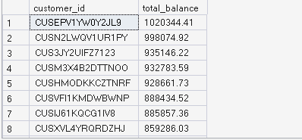

-- Q2. Find the top 10 customers by account balance using RANK.

WITH customer_balance AS
(
SELECT
customer_id,
SUM(balance_usd) AS total_balance
FROM analytics.accounts
GROUP BY customer_id
)
SELECT TOP 10
customer_id,
total_balance,
RANK() OVER (ORDER BY total_balance DESC) AS balance_rank
FROM customer_balance
ORDER BY balance_rank;

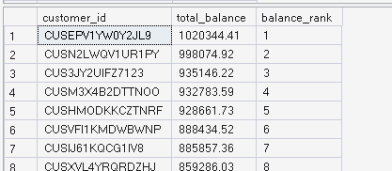
-- Q3. Rank customers based on total transaction value.

WITH customer_transactions AS
(
SELECT
a.customer_id,
SUM(t.amount_usd) AS total_spent
FROM analytics.transactions t
JOIN analytics.accounts a
ON t.account_id = a.account_id
GROUP BY a.customer_id
)
SELECT
customer_id,
total_spent,
RANK() OVER (ORDER BY total_spent DESC) AS spending_rank
FROM customer_transactions
ORDER BY spending_rank;
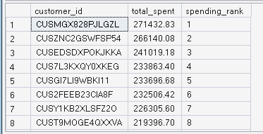

-- Q4. Find the top 3 customers from each account type by balance.

WITH ranked_accounts AS
(
SELECT
a.account_type,
a.customer_id,
SUM(a.balance_usd) AS total_balance,
ROW_NUMBER() OVER
(
PARTITION BY a.account_type
ORDER BY SUM(a.balance_usd) DESC
) AS row_num
FROM analytics.accounts a
GROUP BY
a.account_type,
a.customer_id
)
SELECT
account_type,
customer_id,
total_balance
FROM ranked_accounts
WHERE row_num <= 3
ORDER BY account_type, total_balance DESC;

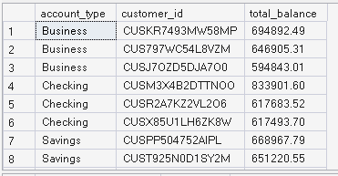
-- Q5. Calculate each customer's percentage contribution
-- to the total transaction value.

WITH customer_transactions AS
(
SELECT
a.customer_id,
SUM(t.amount_usd) AS total_spent
FROM analytics.transactions t
JOIN analytics.accounts a
ON t.account_id = a.account_id
GROUP BY a.customer_id
)
SELECT
customer_id,
total_spent,
total_spent * 100.0 /
(SELECT SUM(total_spent) FROM customer_transactions)
AS spending_percentage
FROM customer_transactions
ORDER BY spending_percentage DESC;
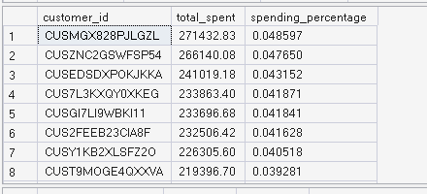

-- Q6. Find customers who have never taken a loan.

SELECT
c.customer_id,
c.first_name,
c.last_name
FROM analytics.customers c
LEFT JOIN analytics.loans l
ON c.customer_id = l.customer_id
WHERE l.customer_id IS NULL;
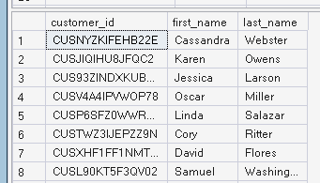

-- Q7. Find customers who have no accounts.

SELECT
c.customer_id,
c.first_name,
c.last_name
FROM analytics.customers c
LEFT JOIN analytics.accounts a
ON c.customer_id = a.customer_id
WHERE a.customer_id IS NULL;

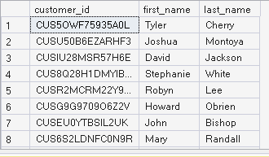

USE PayFlowAnalytics;
GO

-- Q1. Which customers have the highest account balance?

SELECT TOP 10
c.customer_id,
c.first_name,
c.last_name,
SUM(a.balance_usd) AS total_balance
FROM analytics.customers c
JOIN analytics.accounts a
ON c.customer_id = a.customer_id
GROUP BY
c.customer_id,
c.first_name,
c.last_name
ORDER BY total_balance DESC;
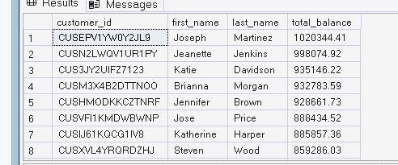

-- Q2. Which customers have the highest loan amount?

SELECT TOP 10
c.customer_id,
c.first_name,
c.last_name,
SUM(l.loan_amount) AS total_loan_amount
FROM analytics.customers c
JOIN analytics.loans l
ON c.customer_id = l.customer_id
GROUP BY
c.customer_id,
c.first_name,
c.last_name
ORDER BY total_loan_amount DESC;
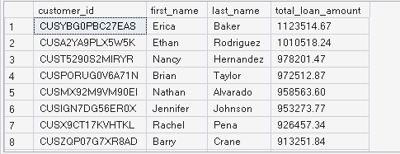

-- Q3. Which customers have both high balance and high loans?

WITH balances AS
(
SELECT
customer_id,
SUM(balance_usd) AS total_balance
FROM analytics.accounts
GROUP BY customer_id
),
loans AS
(
SELECT
customer_id,
SUM(loan_amount) AS total_loan_amount
FROM analytics.loans
GROUP BY customer_id
)
SELECT
c.customer_id,
c.first_name,
c.last_name,
b.total_balance,
l.total_loan_amount
FROM analytics.customers c
JOIN balances b
ON c.customer_id = b.customer_id
JOIN loans l
ON c.customer_id = l.customer_id
WHERE b.total_balance > 100000
AND l.total_loan_amount > 100000
ORDER BY
b.total_balance DESC;

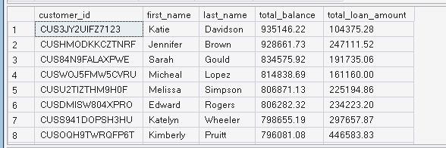
-- Q4. Which customers have the highest transaction spending?

SELECT TOP 10
c.customer_id,
c.first_name,
c.last_name,
SUM(t.amount_usd) AS total_spent
FROM analytics.transactions t
JOIN analytics.accounts a
ON t.account_id = a.account_id
JOIN analytics.customers c
ON a.customer_id = c.customer_id
GROUP BY
c.customer_id,
c.first_name,
c.last_name
ORDER BY total_spent DESC;
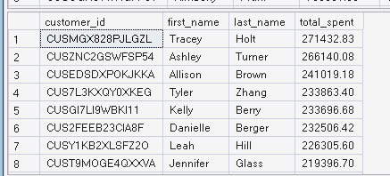

-- Q5. What is the customer credit-score distribution?

SELECT
CASE
WHEN credit_score BETWEEN 300 AND 579 THEN 'Low'
WHEN credit_score BETWEEN 580 AND 669 THEN 'Medium'
WHEN credit_score BETWEEN 670 AND 739 THEN 'Good'
ELSE 'Excellent'
END AS credit_category,
COUNT(*) AS customer_count
FROM analytics.customers
GROUP BY
CASE
WHEN credit_score BETWEEN 300 AND 579 THEN 'Low'
WHEN credit_score BETWEEN 580 AND 669 THEN 'Medium'
WHEN credit_score BETWEEN 670 AND 739 THEN 'Good'
ELSE 'Excellent'
END
ORDER BY customer_count DESC;

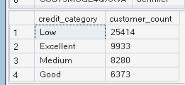
-- Q6. What are the overall banking KPIs?

SELECT
(SELECT COUNT(*) FROM analytics.customers) AS total_customers,
(SELECT COUNT(*) FROM analytics.accounts) AS total_accounts,
(SELECT SUM(balance_usd) FROM analytics.accounts) AS total_balance,
(SELECT COUNT(*) FROM analytics.loans) AS total_loans,
(SELECT SUM(loan_amount) FROM analytics.loans) AS total_loan_amount,
(SELECT COUNT(*) FROM analytics.transactions) AS total_transactions,
(SELECT SUM(amount_usd) FROM analytics.transactions) AS total_transaction_value;

-- Q1. Customer-level master analysis table

WITH account_summary AS
(
SELECT
customer_id,
COUNT(account_id) AS account_count,
SUM(balance_usd) AS total_balance
FROM analytics.accounts
GROUP BY customer_id
),
loan_summary AS
(
SELECT
customer_id,
COUNT(loan_id) AS loan_count,
SUM(loan_amount) AS total_loan_amount,
AVG(interest_rate) AS average_interest_rate
FROM analytics.loans
GROUP BY customer_id
),
transaction_summary AS
(
SELECT
a.customer_id,
COUNT(t.transaction_id) AS transaction_count,
SUM(t.amount_usd) AS total_spent,
AVG(t.amount_usd) AS average_transaction
FROM analytics.transactions t
JOIN analytics.accounts a
ON t.account_id = a.account_id
GROUP BY a.customer_id
)
SELECT
c.customer_id,
c.first_name,
c.last_name,
c.city,
c.credit_score,
CASE
WHEN c.credit_score BETWEEN 300 AND 579 THEN 'Low'
WHEN c.credit_score BETWEEN 580 AND 669 THEN 'Medium'
WHEN c.credit_score BETWEEN 670 AND 739 THEN 'Good'
ELSE 'Excellent'
END AS credit_category,
COALESCE(a.account_count, 0) AS account_count,
COALESCE(a.total_balance, 0) AS total_balance,
COALESCE(l.loan_count, 0) AS loan_count,
COALESCE(l.total_loan_amount, 0) AS total_loan_amount,
COALESCE(l.average_interest_rate, 0) AS average_interest_rate,
COALESCE(t.transaction_count, 0) AS transaction_count,
COALESCE(t.total_spent, 0) AS total_spent,
COALESCE(t.average_transaction, 0) AS average_transaction
FROM analytics.customers c
LEFT JOIN account_summary a
ON c.customer_id = a.customer_id
LEFT JOIN loan_summary l
ON c.customer_id = l.customer_id
LEFT JOIN transaction_summary t
ON c.customer_id = t.customer_id;
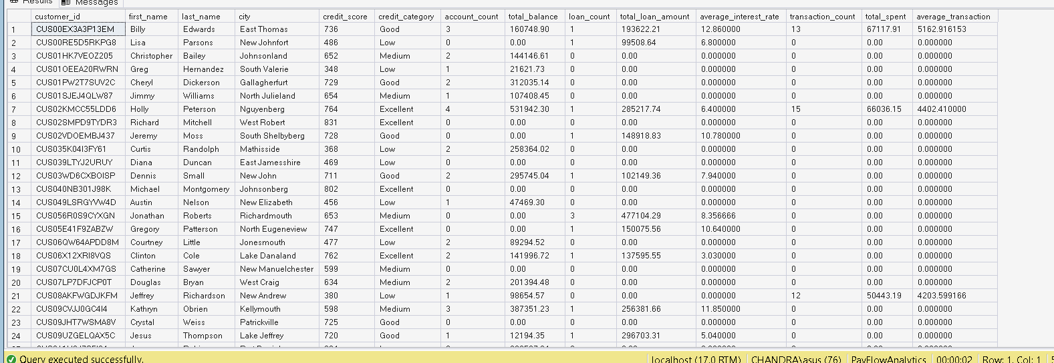

-- Q1. Total number of customers
SELECT COUNT(*) AS Total_Customers
FROM analytics.customers;

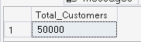
-- Q2. Average customer credit score
SELECT AVG(credit_score) AS Average_Credit_Score
FROM analytics.customers;
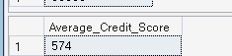

-- Q3. Total number of accounts
SELECT COUNT(*) AS Total_Accounts
FROM analytics.accounts;
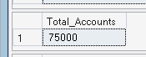

-- Q4. Average account balance
SELECT AVG(balance_usd) AS Average_Account_Balance
FROM analytics.accounts;
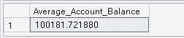

-- Q5. Total banking balance
SELECT SUM(balance_usd) AS Total_Bank_Balance
FROM analytics.accounts;
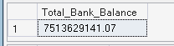

-- Q6. Total number of loans
SELECT COUNT(*) AS Total_Loans
FROM analytics.loans;
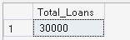

-- Q7. Total loan amount
SELECT SUM(loan_amount) AS Total_Loan_Amount
FROM analytics.loans;
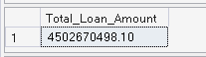

-- Q8. Total transaction value
SELECT SUM(amount_usd) AS Total_Transaction_Value
FROM analytics.transactions;
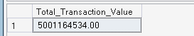

-- Q9. Total number of transactions
SELECT COUNT(*) AS Total_Transactions
FROM analytics.transactions;
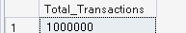

-- Q10. Average transaction value
SELECT AVG(amount_usd) AS Average_Transaction_Value
FROM analytics.transactions;
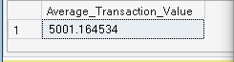

USE PayFlowAnalytics;
GO

-- Q1. Classify customers based on credit score
SELECT
customer_id,
credit_score,
CASE
WHEN credit_score < 580 THEN 'Low'
WHEN credit_score < 670 THEN 'Medium'
WHEN credit_score < 740 THEN 'Good'
ELSE 'Excellent'
END AS Credit_Category
FROM analytics.customers;
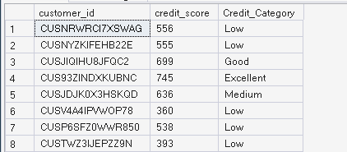

-- Q2. Find customers with high account balances
SELECT
customer_id,
SUM(balance_usd) AS Total_Balance
FROM analytics.accounts
GROUP BY customer_id
HAVING SUM(balance_usd) > 100000
ORDER BY Total_Balance DESC;

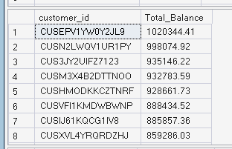
-- Q3. Find top 10 customers by total spending
SELECT TOP 10
a.customer_id,
SUM(t.amount_usd) AS Total_Spending
FROM analytics.accounts a
JOIN analytics.transactions t
ON a.account_id = t.account_id
GROUP BY a.customer_id
ORDER BY Total_Spending DESC;
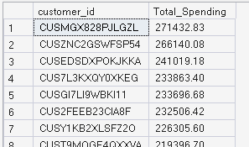

-- Q4. Find customers who have both accounts and loans
SELECT
c.customer_id,
COUNT(DISTINCT a.account_id) AS Account_Count,
COUNT(DISTINCT l.loan_id) AS Loan_Count
FROM analytics.customers c
JOIN analytics.accounts a
ON c.customer_id = a.customer_id
JOIN analytics.loans l
ON c.customer_id = l.customer_id
GROUP BY c.customer_id
ORDER BY Account_Count DESC;
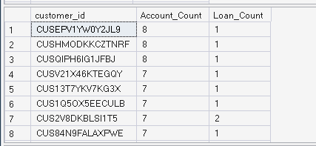

-- Q5. Find high-credit-score customers with high balances
SELECT
c.customer_id,
c.credit_score,
SUM(a.balance_usd) AS Total_Balance
FROM analytics.customers c
JOIN analytics.accounts a
ON c.customer_id = a.customer_id
WHERE c.credit_score >= 740
GROUP BY c.customer_id, c.credit_score
HAVING SUM(a.balance_usd) > 100000
ORDER BY Total_Balance DESC;
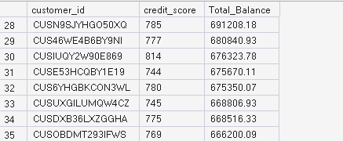

-- Q6. Find customers with more than 3 accounts
SELECT
customer_id,
COUNT(*) AS Account_Count
FROM analytics.accounts
GROUP BY customer_id
HAVING COUNT(*) > 3
ORDER BY Account_Count DESC;

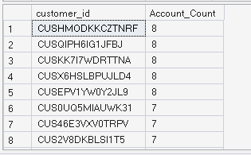

Loan Size Category =
SWITCH(
TRUE(),
'analytics loans'[loan_amount] <= 100000, "Small",
'analytics loans'[loan_amount] <= 200000, "Medium",
"Large"
)
Loan Year = YEAR('analytics loans'[start_date])

Low Credit Customers =
CALCULATE(
DISTINCTCOUNT('analytics customers'[customer_id]),
'analytics customers'[credit_score] < 580
)

Good Excellent Customers =
CALCULATE(
DISTINCTCOUNT('analytics customers'[customer_id]),
'analytics customers'[credit_score] >= 670
)

Customers Multiple Accounts =
COUNTROWS(
FILTER(
VALUES('analytics accounts'[customer_id]),
CALCULATE(
COUNT('analytics accounts'[account_id])
) > 1
)
)

Avg Accounts per Customer =
DIVIDE(
COUNT('analytics accounts'[account_id]),
DISTINCTCOUNT('analytics accounts'[customer_id])
)
Total Account Balance =
SUM('analytics accounts'[balance_usd])

Average Account Balance =
AVERAGE('analytics accounts'[balance_usd])

Total Cards =
DISTINCTCOUNT('analytics cards'[card_id])

Expired Cards =
CALCULATE(
DISTINCTCOUNT('analytics cards'[card_id]),
'analytics cards'[card_status] = "Expired"
)

Unmatched Transaction Accounts =
CALCULATE(
DISTINCTCOUNT('analytics transactions'[account_id]),
FILTER(
'analytics transactions',
NOT(
'analytics transactions'[account_id]
IN VALUES('analytics accounts'[account_id])
)
)
)
Unmatched Transaction Merchants =
CALCULATE(
DISTINCTCOUNT('analytics transactions'[merchant_id]),
FILTER(
'analytics transactions',
NOT(
'analytics transactions'[merchant_id]
IN VALUES('analytics merchants'[merchant_id])
)
)
)
Duplicate Email Groups =
COUNTROWS(
FILTER(
VALUES('analytics customers'[email]),
CALCULATE(
COUNTROWS('analytics customers')
) > 1
)
)
Account Date Exceptions =
COUNTROWS(
FILTER(
'analytics accounts',
'analytics accounts'[open_date]
< LOOKUPVALUE(
'analytics customers'[created_at],
'analytics customers'[customer_id],
'analytics accounts'[customer_id]
)
)
)
Matched Transaction Records =
COUNTROWS(
FILTER(
'analytics transactions',
'analytics transactions'[account_id]
IN VALUES('analytics accounts'[account_id])
)
)
Unmatched Transaction Records =
COUNTROWS(
FILTER(
'analytics transactions',
NOT(
'analytics transactions'[account_id]
IN VALUES('analytics accounts'[account_id])
)
)
)

Matched Merchant Records =
COUNTROWS(
FILTER(
'analytics transactions',
'analytics transactions'[merchant_id]
IN VALUES('analytics merchants'[merchant_id])
)
)

Unmatched Merchant Records =
COUNTROWS(
FILTER(
'analytics transactions',
NOT(
'analytics transactions'[merchant_id]
IN VALUES('analytics merchants'[merchant_id])
)
)
)

